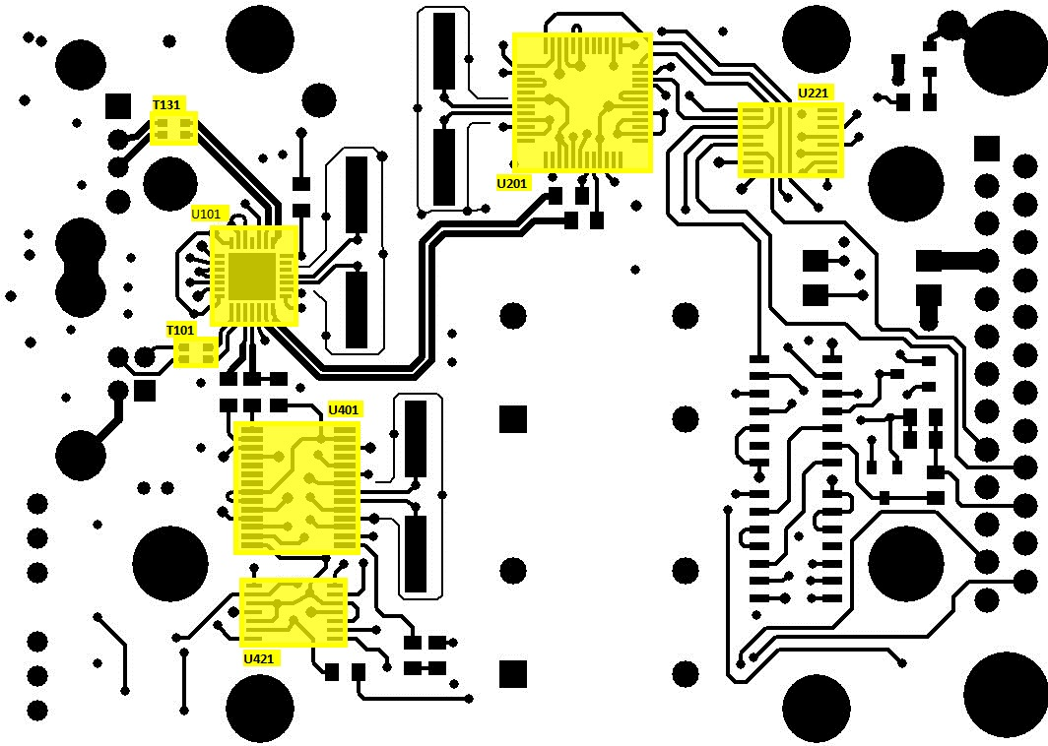

T101, T131 : 0805USB-901MLB

U101 : CY7C65632-28LTXC

U201 : FT2232D

U221 : MAX3232IPWR

U401 : PCM2902CDB

U421 : LMV324IPWR
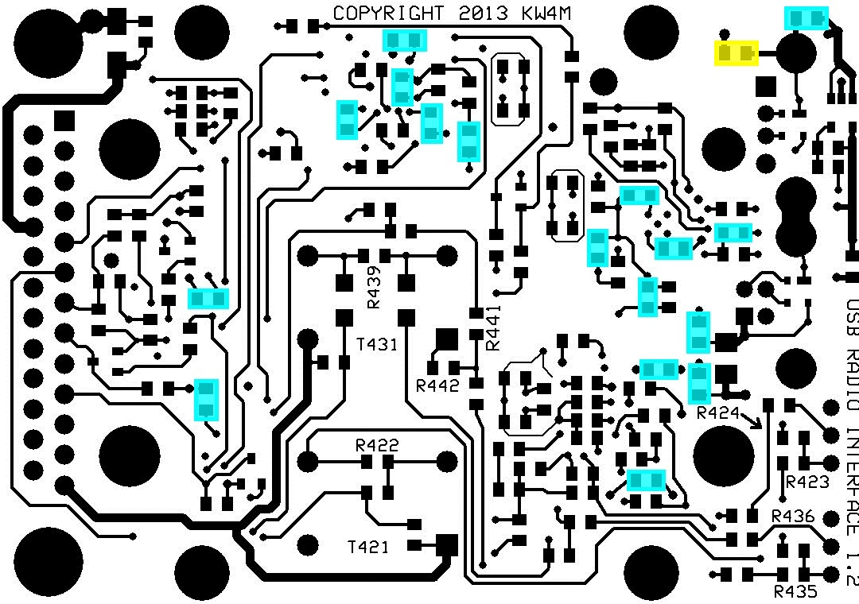

17 - C101-102,C104-106,C109,C111,C201-204,C206,C301,C311,C401,C421,C451 : C0805C104K5RACTU

1 – C103 : GRM219C81A475KE34D
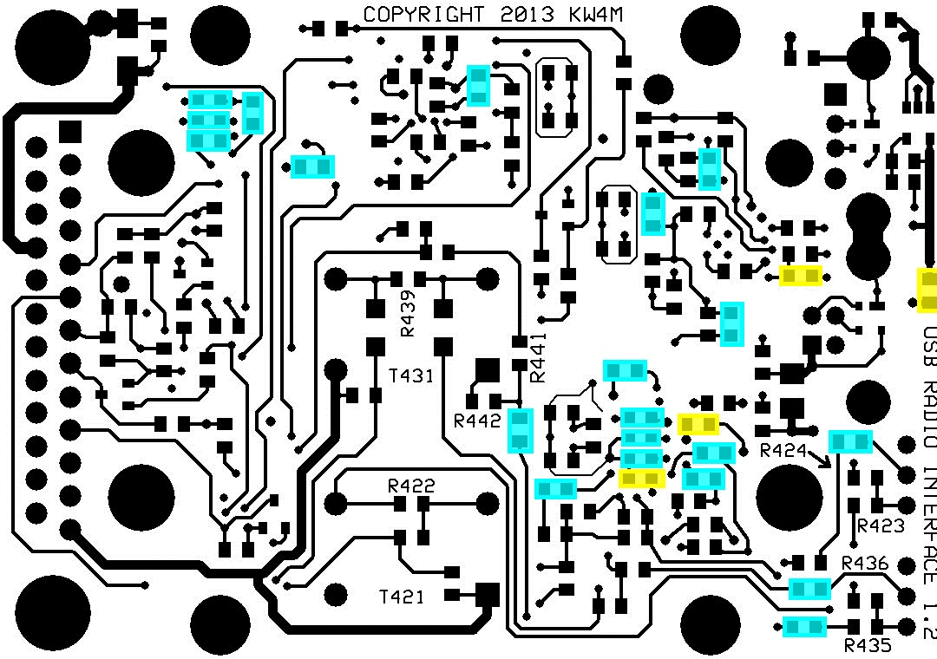

20 - C107-108,C112,C205,C221-225,C403-405,C407,C424-425,C431,C434-435,C443-444 : C0805C105K4RACTU

4 - C110,C402,C406,C452 : GRM21BR61A106KE19L

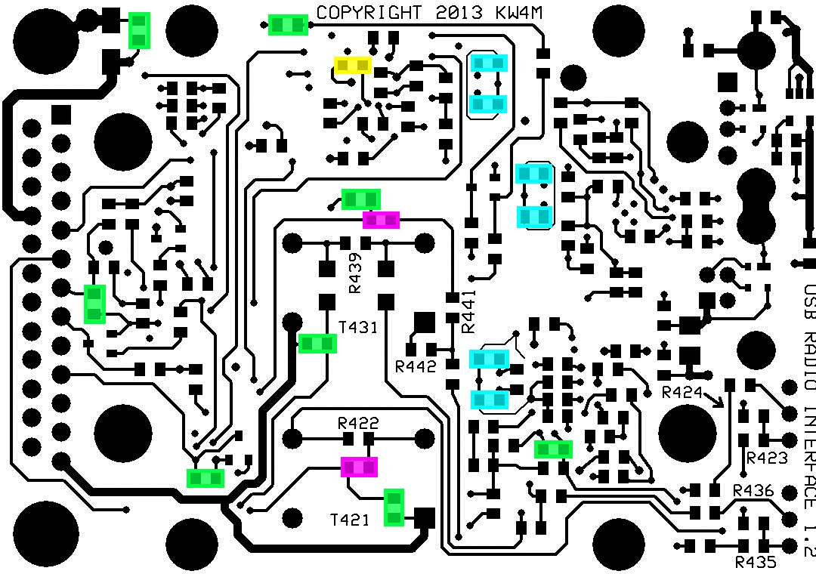

6 - C113-114,C207-208,C408-409 : C0805C360J5GACTU

1 – C209 : C0805C333K5RACTU

8 - C302,C331,C351,C381,C422,C433,C438,C441 : C0805C102J5GACTU

2 - C423,C442 : UMK212BJ105KG-T

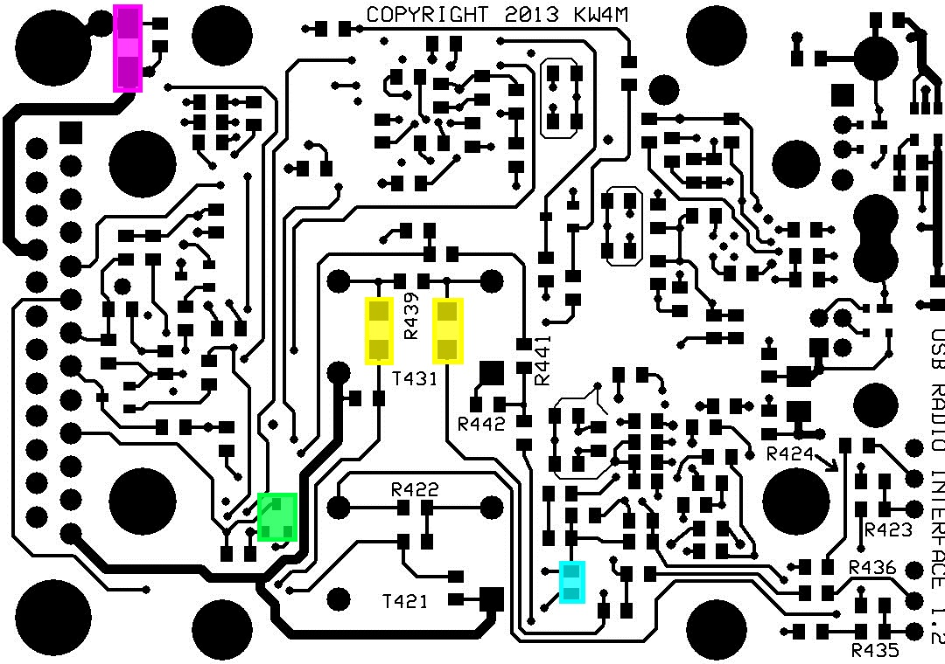

1 – C432 : GRM2165C1H392JA01D

2 - C436-437 : C3216Y5V1E106Z

1 – D302 : BAT54SFILM

1 – D331 : S1M-13-F

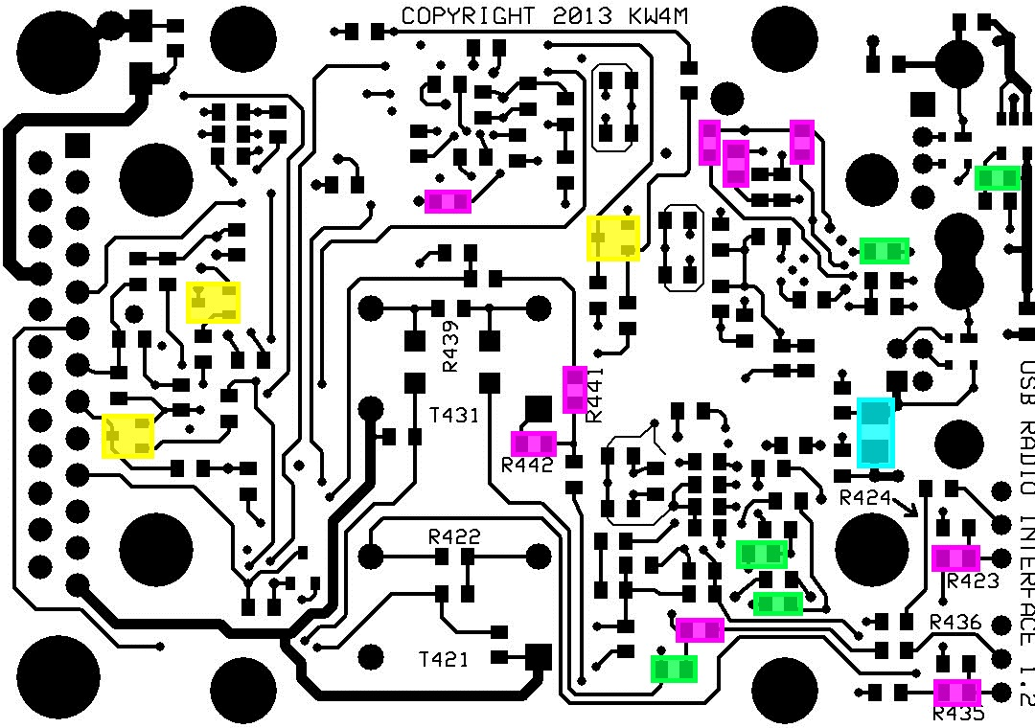

1 – FB101 : MI1206K601R-10

3 - Q301,Q341,Q381 : NSS40201LT1G

5 - R101,R426,R438,R444,R451 : ERJ-6ENF1003V

9 - R102,R104,R106,R212,R423,R435,R437,R441-442 : ERJ-6ENF1002V

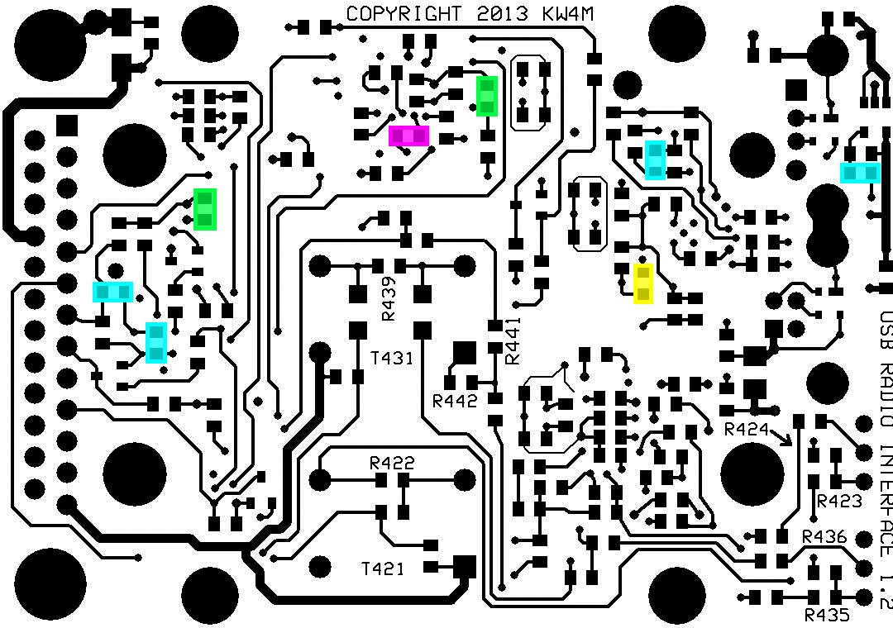

4 - R103,R352-353,R452 : ERJ-6ENF4872V

1 – R105 : ERJ-6ENF6490V

2 - R201,R342 : ERJ-6ENF5100V

1 – R202 : ERJ-6ENF1501V

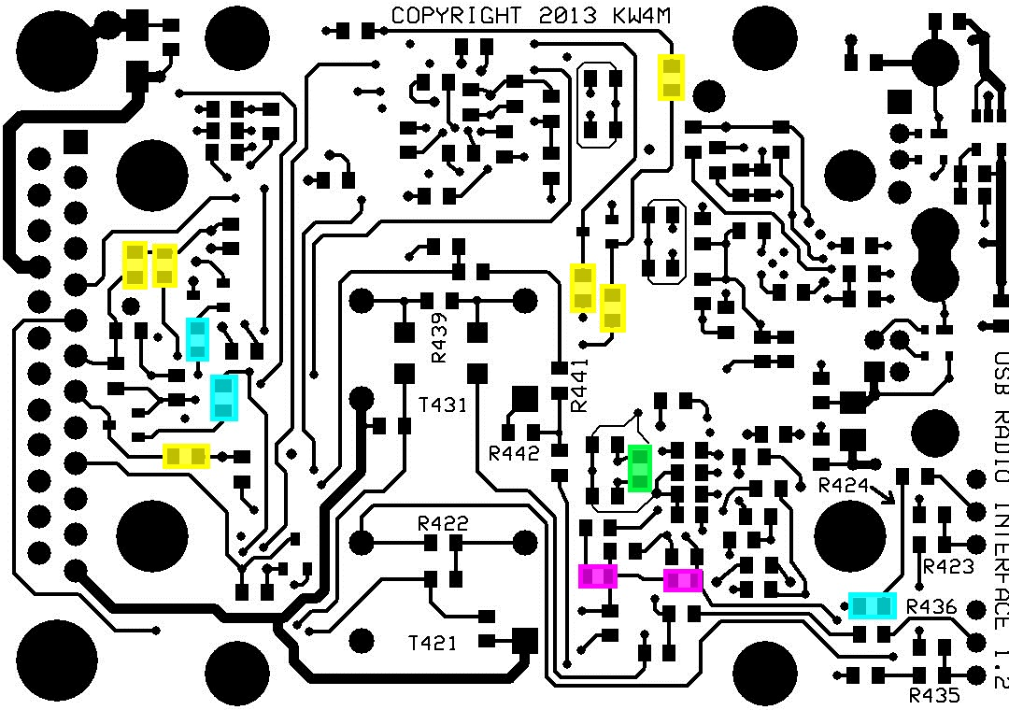

3 - R301,R341,R425 : ERJ-6ENF5101V

6 - R302,R351,R354,R381-383 : ERJ-6ENF2202V

1 – R402 : ERJ-6ENF1004V

2 - R432,R434 : ERJ-6ENF1622V

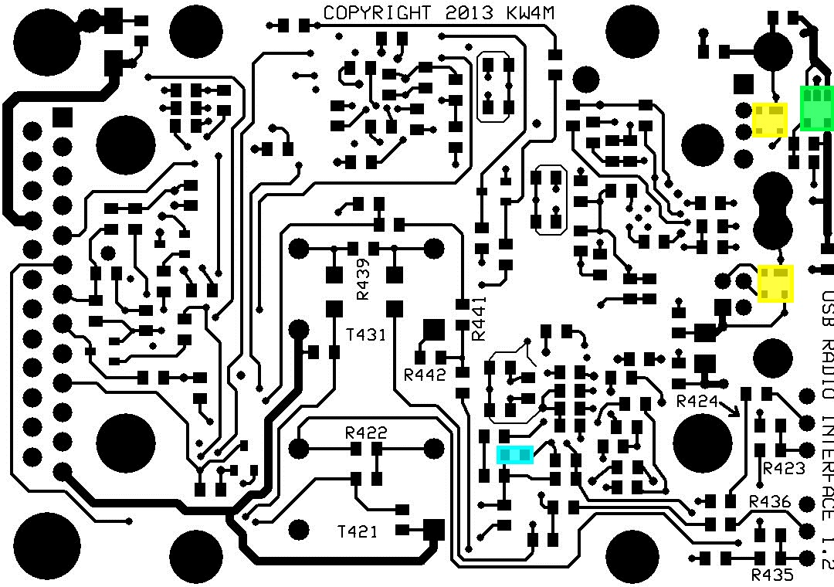

1 – R433 : ERJ-6ENF8251V

2 - U111,U131 : PRTR5V0U2X

1 - U451 : MIC5225YM5_TR

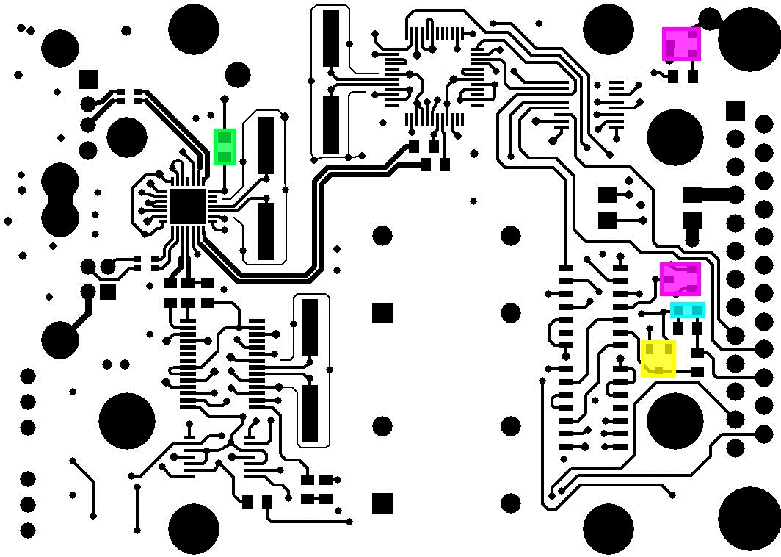

1 – C361 : C0805C102J5GACTU (same as C302)

1 – D361 : BAT54SFILM (same as D302)

1 – FB102 : MI0805M221R-10

2 - Q331,Q351 : NSS40201LT1G (same as Q301)

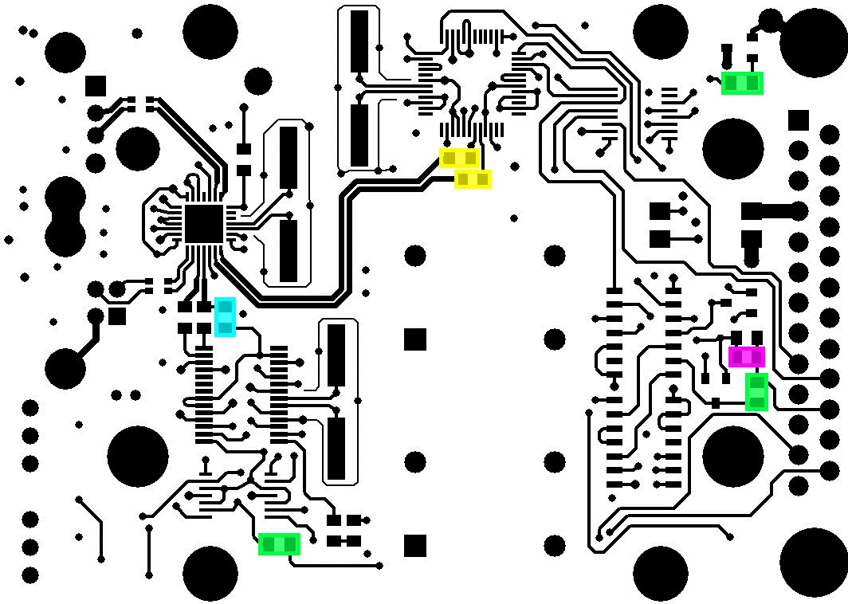

1 – R401 : ERJ-6ENF1501V (same as R202)

2 – R204,R205 : ERJ-6ENF27R0V

3 - R331,R362,R443 : ERJ-6ENF5101V (same as R301)

1 – R361 : ERJ-6ENF2202V (same as R302)
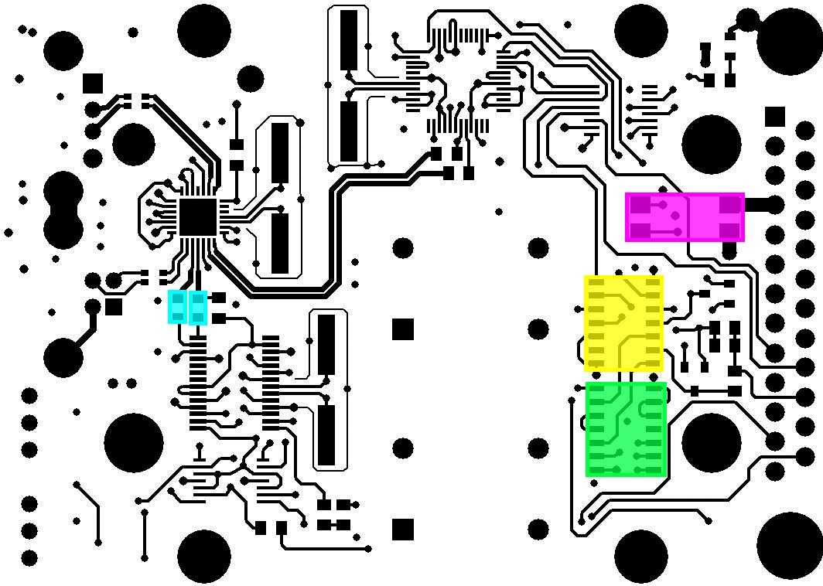

2 – R403,R404 : ERJ-6ENF22R0V

1 – U301 : SN74HCT04DR

1 – U311 : SN74HCT08DR

1 – U341 : AQY210EHAX
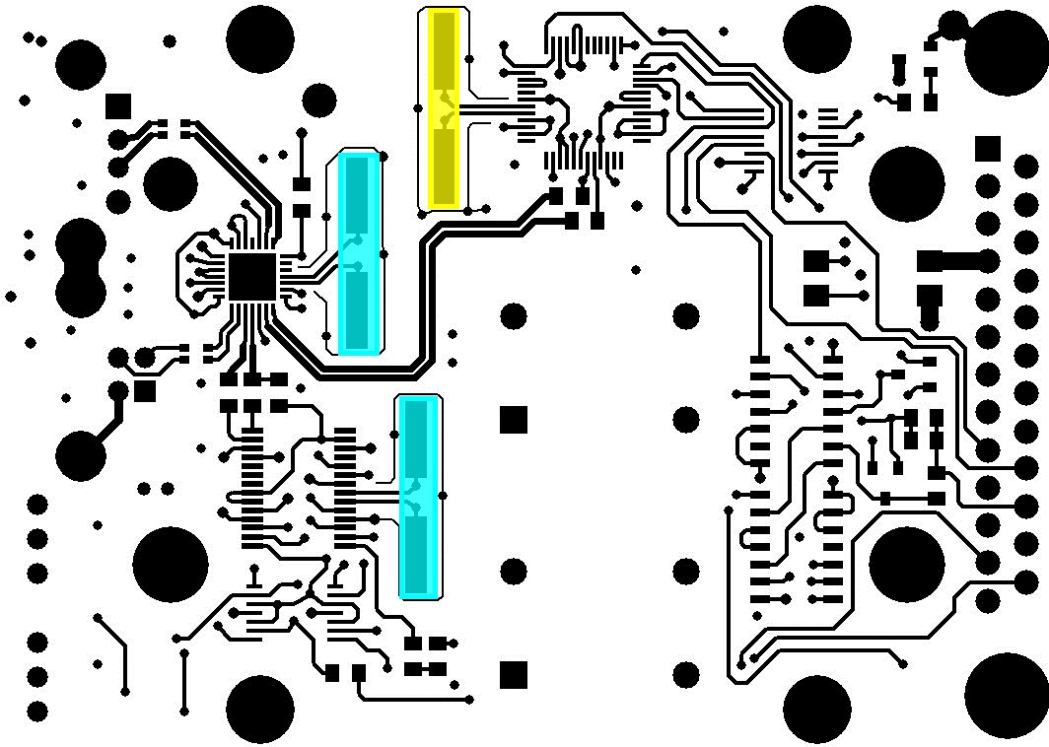

2 – X101,X401 : ATS120BSM-1

1 – X201 - ATS060BSM-1

